Affinity Diagrams

IDEA: How would the user interact with the component?

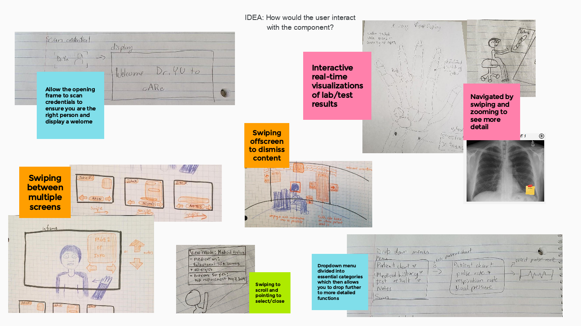

IDEA: Organization of components creating the display the user sees

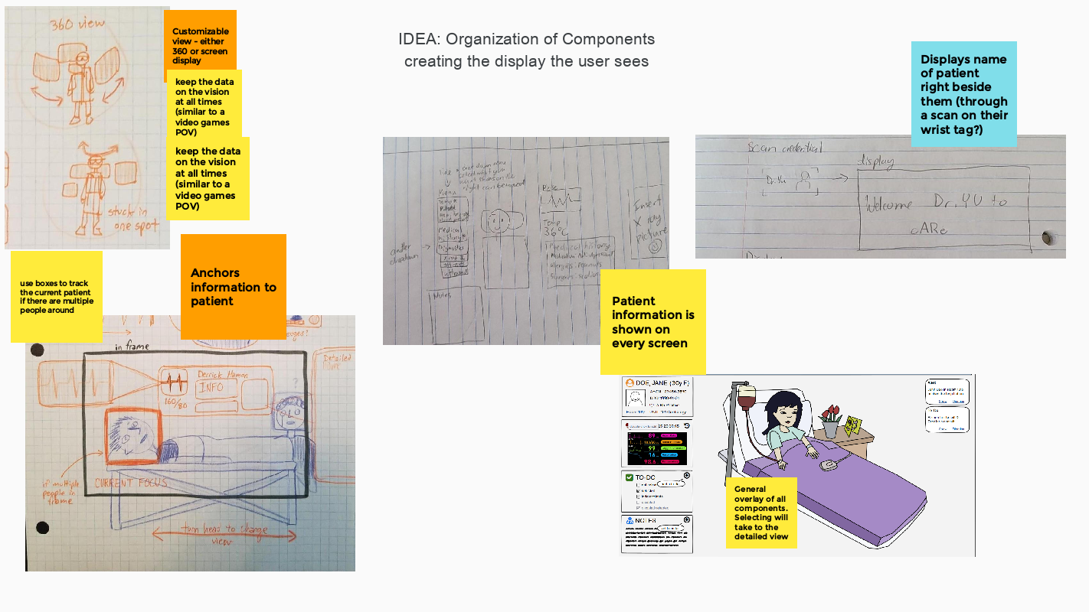

IDEA: How should individual components look?

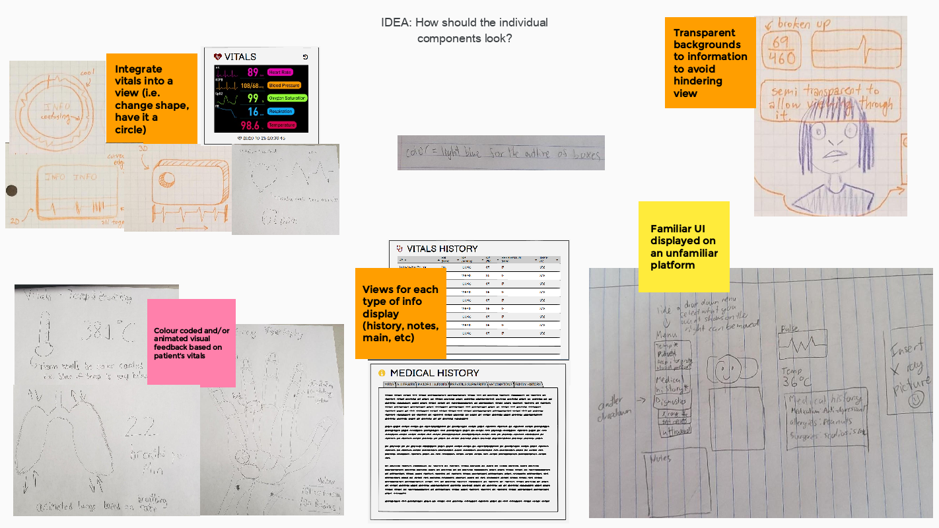

IDEA: How would the user personalize their settings?

